**k-Nearest Neighbors (k-NN) algorithm in Weka**

**1. Open Weka**

* **Launch the Weka application. You should see the Weka GUI Chooser with options like "Explorer," "Experimenter," "KnowledgeFlow," and "Simple CLI."**

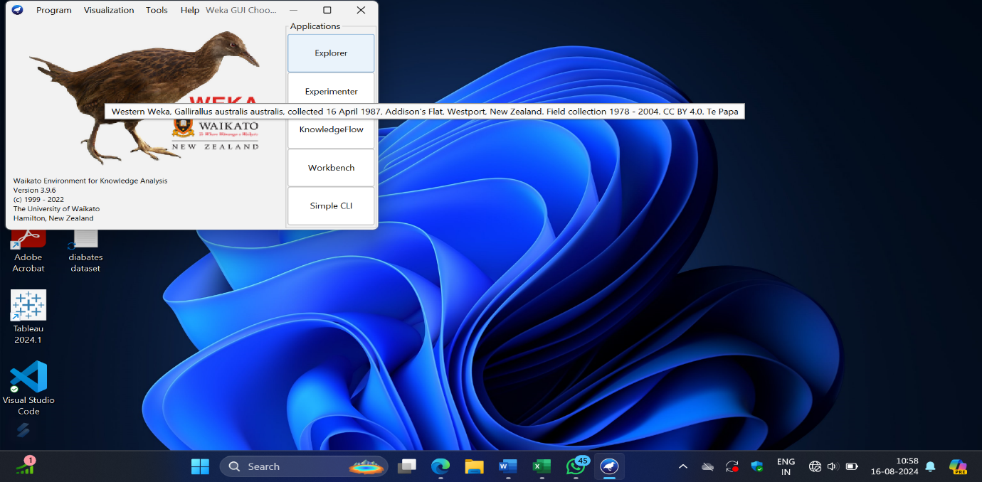

**2. Load Your Data**

1. **Click on "Explorer": This opens the Weka Explorer interface.**



1. **Load Dataset:**
   * **Click on the “Open file...” button.**

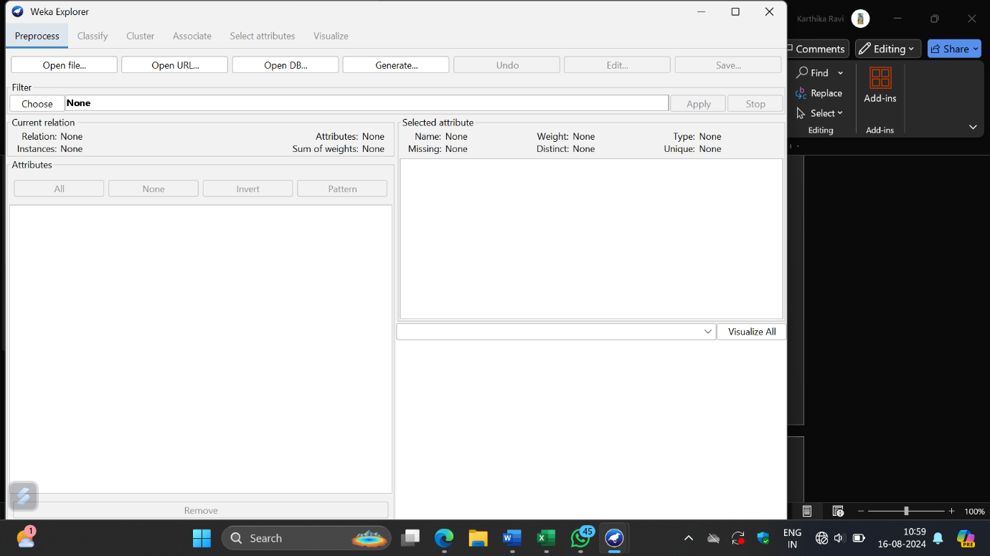

* + **Browse to the location of your dataset (it should be in ARFF or CSV format).**
  + **Select the file and click “Open.” The dataset is loaded.**

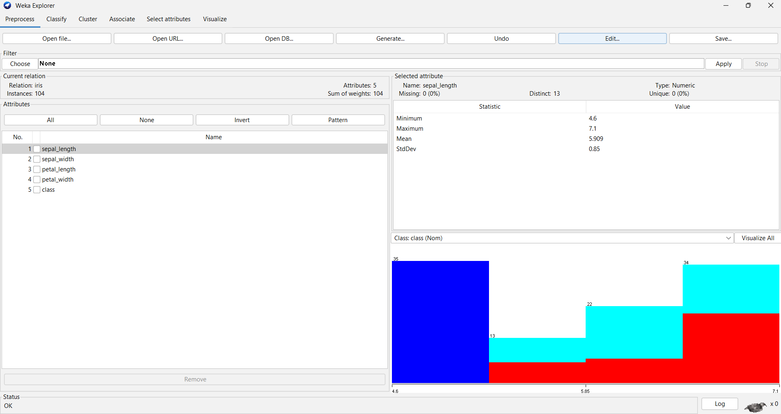

**Apply the resample filter to get the sub sample of the dataset.**

**Filter\choose\filter\supervised\instance \resample\apply**

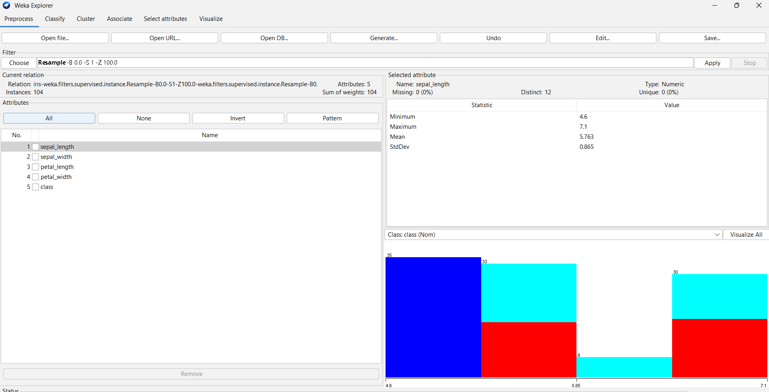

**3. Choose the k-NN Algorithm**

1. **Select the "Classify" Tab: This tab allows you to choose and configure classifiers.**

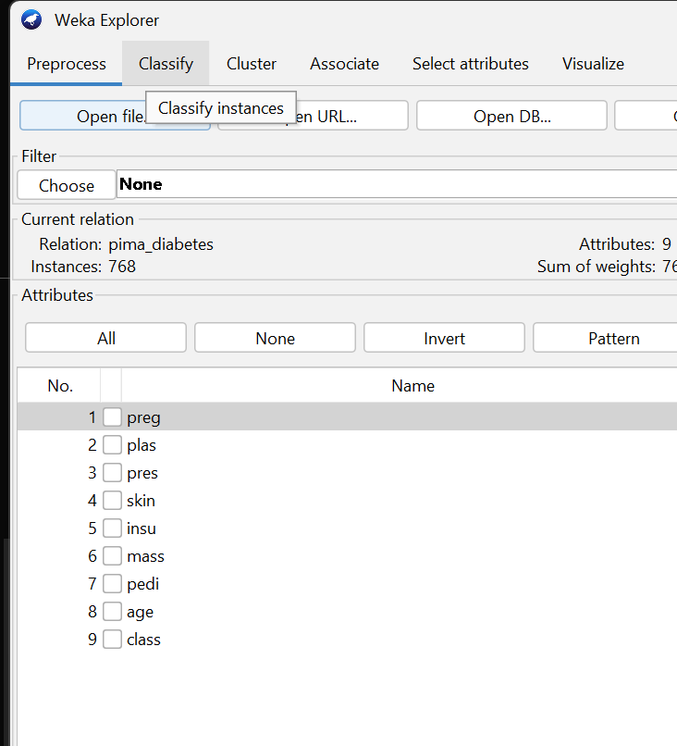

1. **Choose the Classifier:**
   * **Click on the “Choose” button which opens a list of available classifiers.**

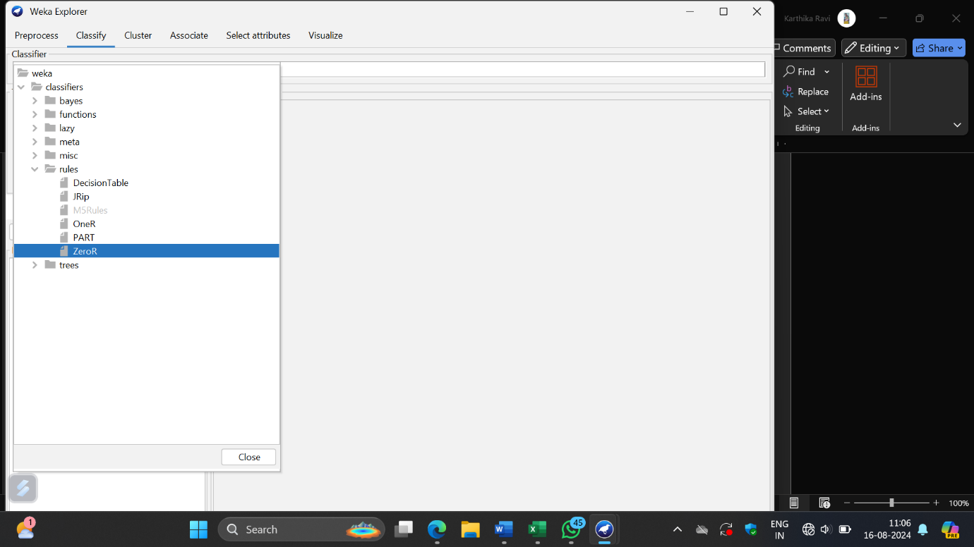

* + **Navigate to lazy and select IBk. IBk is Weka’s implementation of the k-Nearest Neighbors algorithm.**

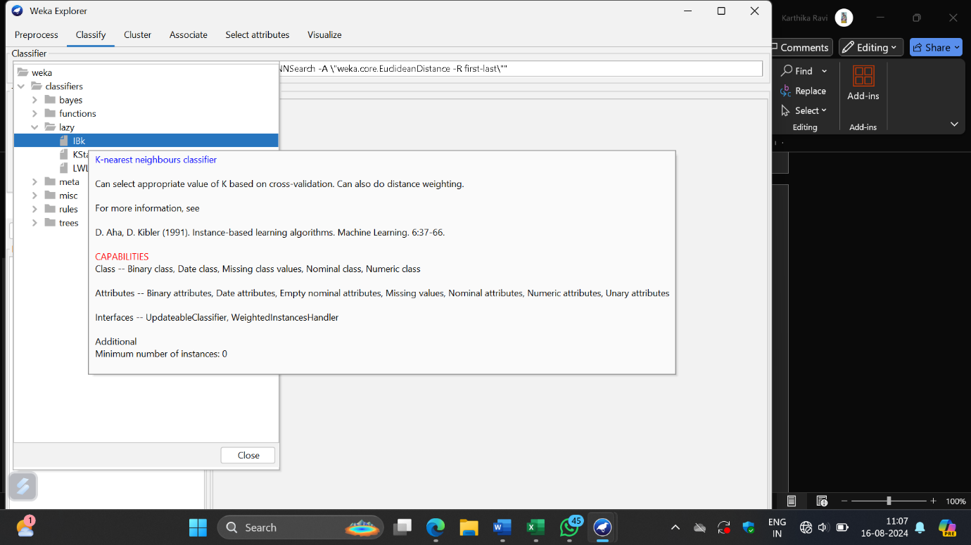

**4. Configure the k-NN Parameters**

1. **Set Parameters:**
   * **After selecting IBk, click on the name (IBk) to open the configuration panel.**

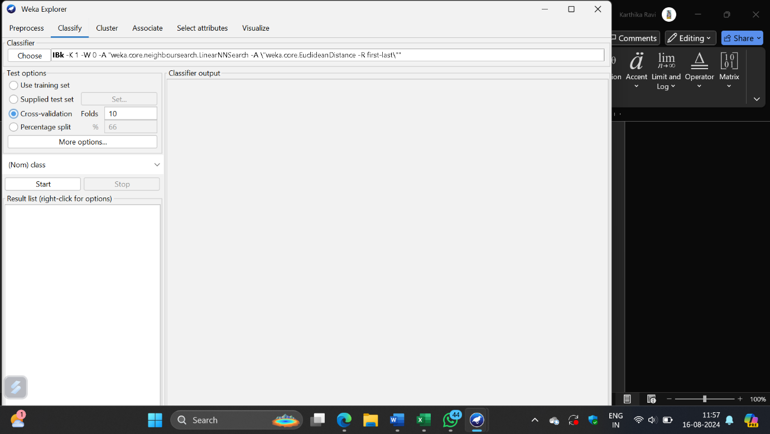

* + **k-Value: Set the number of neighbors (k). The default is usually 1, but you can adjust this based on your needs. For example, you might want to try different values like 3, 5, or 10.**
  + **Distance Function: Choose the distance function (Euclidean is commonly used, but there are other options).**
  + **Normalization: You may want to normalize the data if your features are on different scales.**

**5. Evaluate the Model**

1. **Split Data Using Percentage Split**

**1.Set Up Percentage Split:**

* **In the "Classify" tab, look for the “Test options” section.**

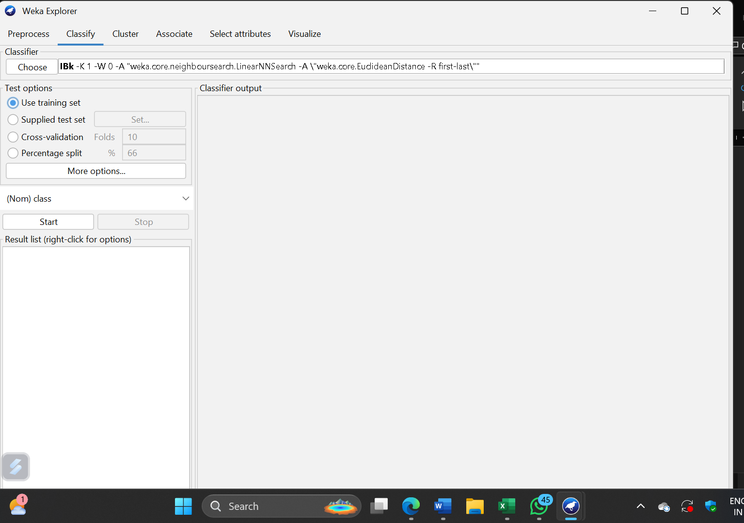

* **Select the “Percentage split” option.**

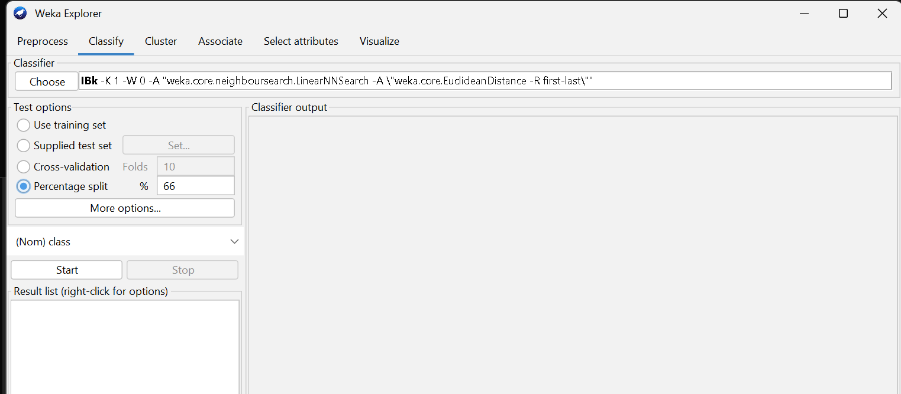

* **Enter the percentage of the dataset you want to use for training (e.g., 66% for training and 34% for testing). The remaining percentage will automatically be used for testing.**

1. **Set Up Cross-Validation:**

* **In the "Classify" tab, look for the “Test options” section.**

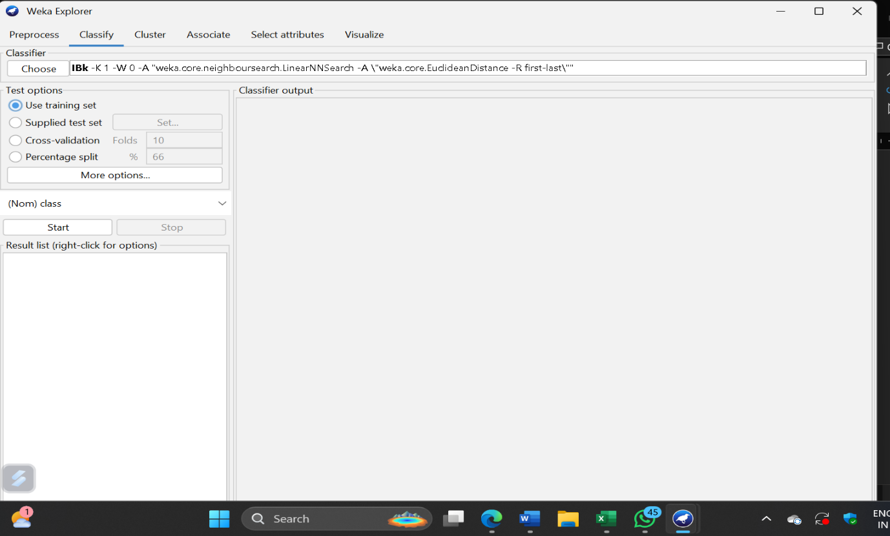

* **Select the “Cross-validation” option.**
* **Enter the number of folds (e.g., 10-fold cross-validation is common).**

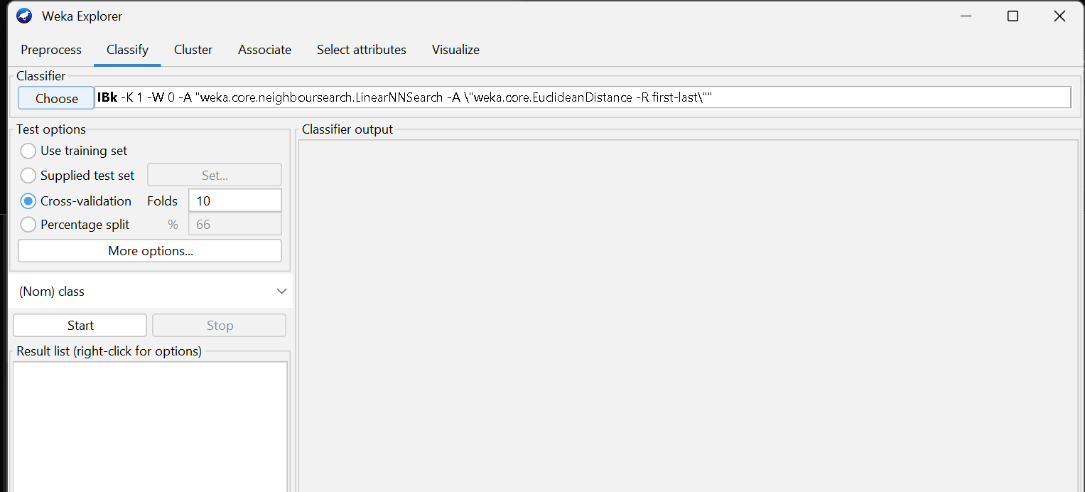

**2.Run the Classification:**

* **Click on the “Start” button to train the k-NN model using the training set and evaluate it using the test set.**
* **Weka will output the results, including accuracy, confusion matrix, and other performance metrics.**

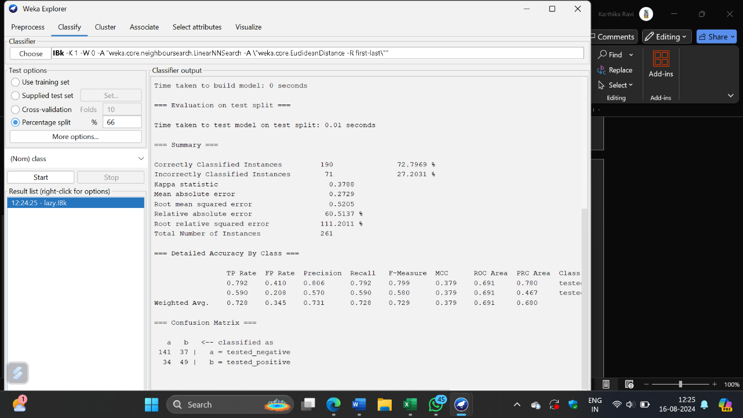

**Now the dataset is trained.**

**To test the dataset go to test option and select supplied test set\click set.**

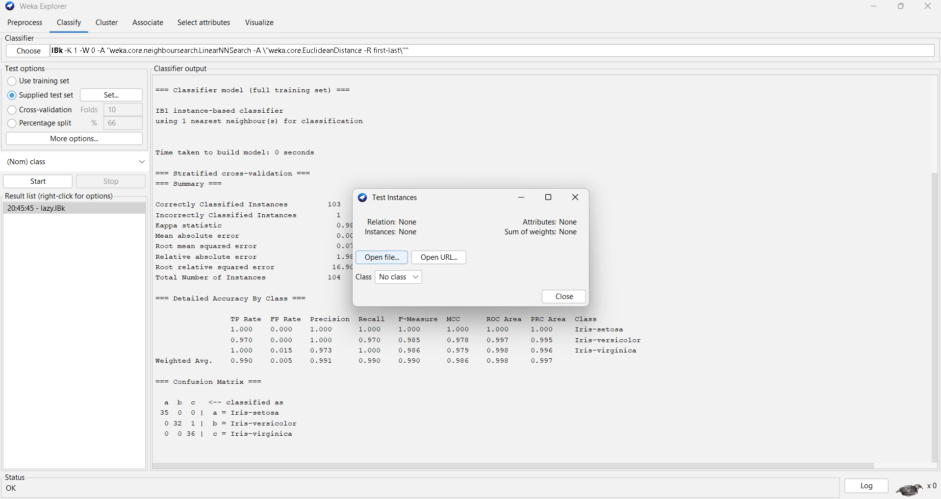

**Select open file and add the test dataset and click start**

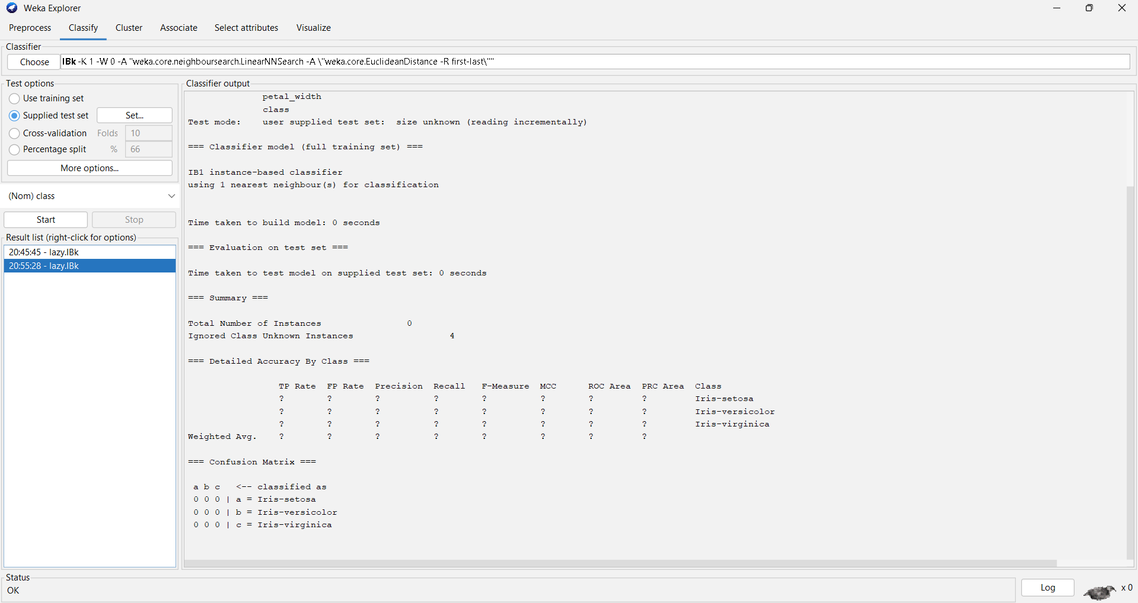

**To view the result go to the result list and right the algorithm and select visualize classifier error.**

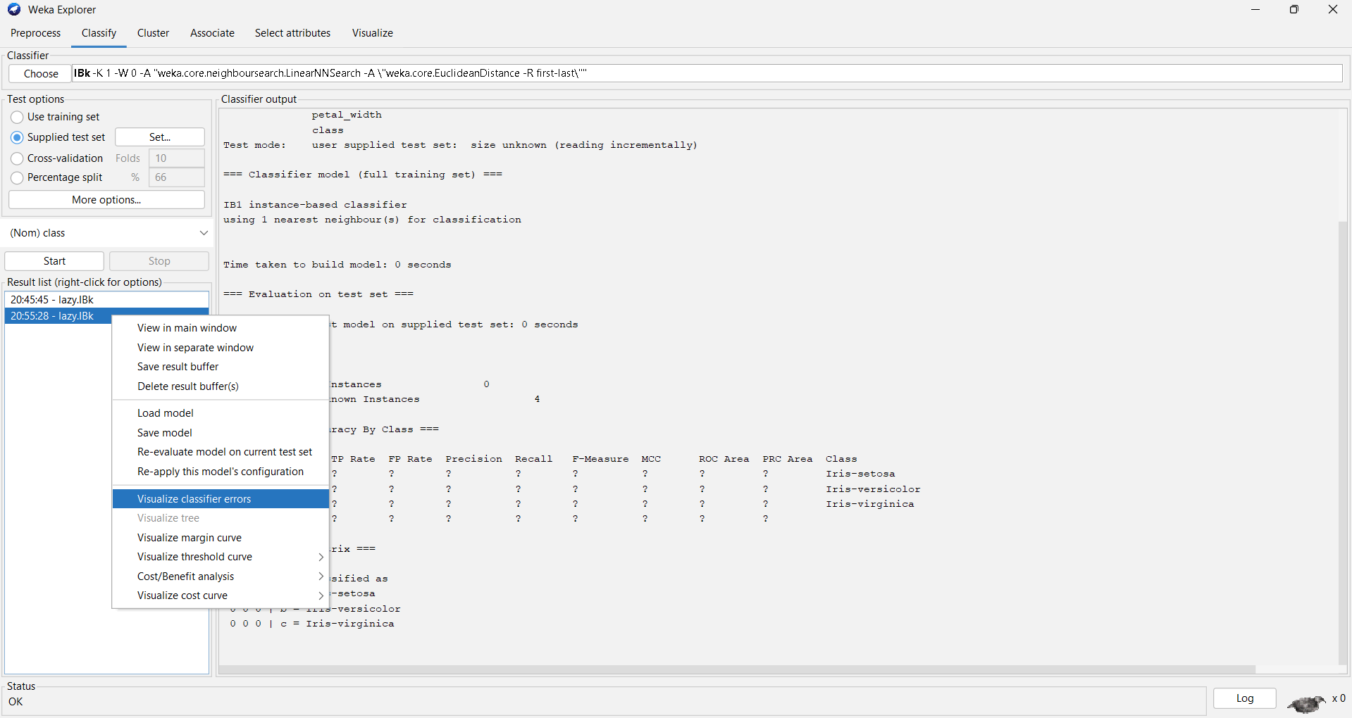

**select visualize classifier error.**

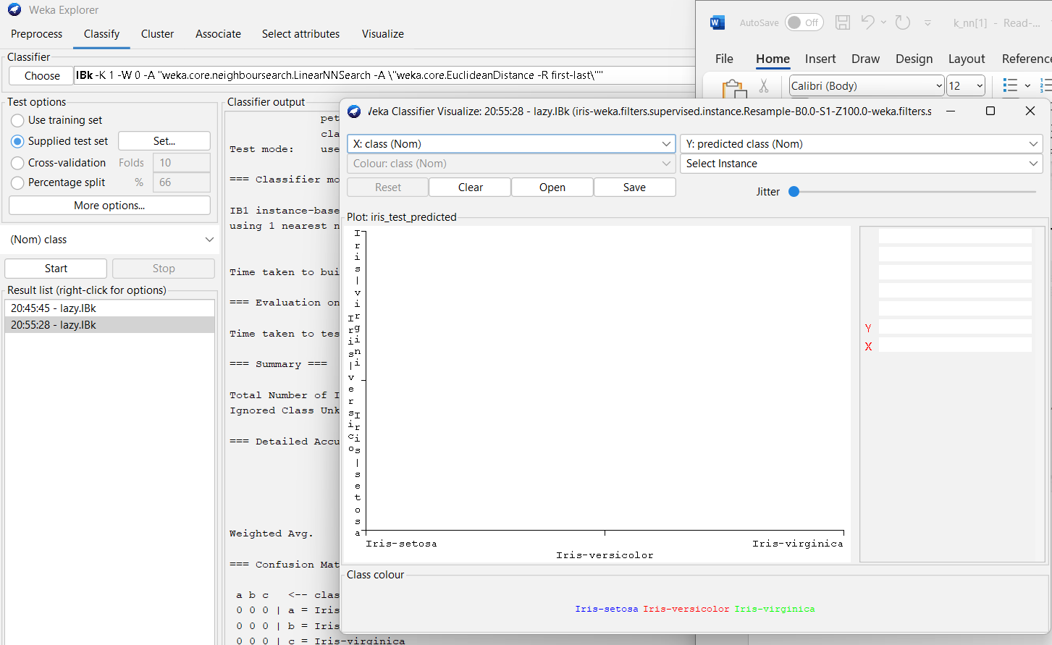

**Click save**

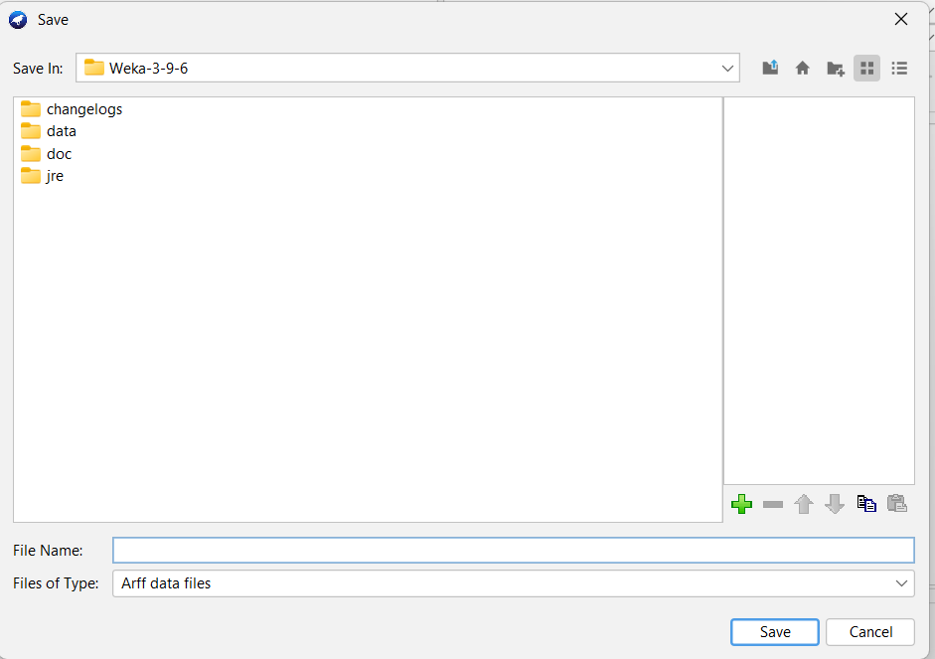

**Save the file where the trained dataset and the testing dataset is saved**

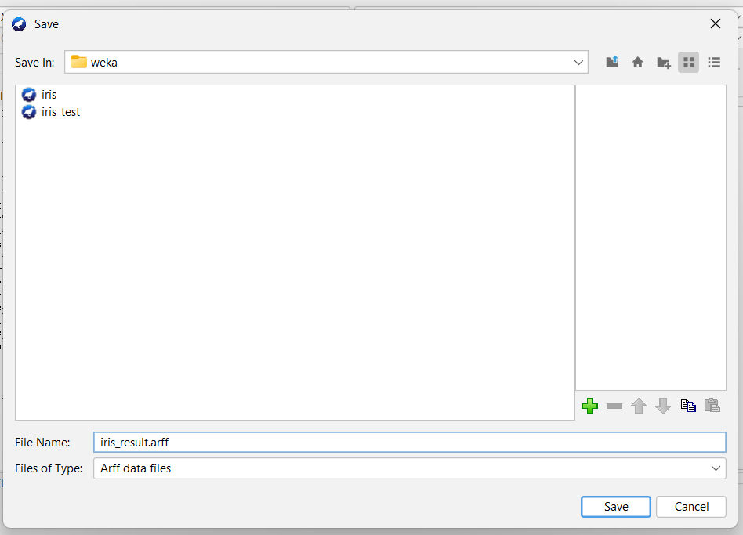

**Go to document\ go to folder where the result is saved \right the result\open with notepad .**

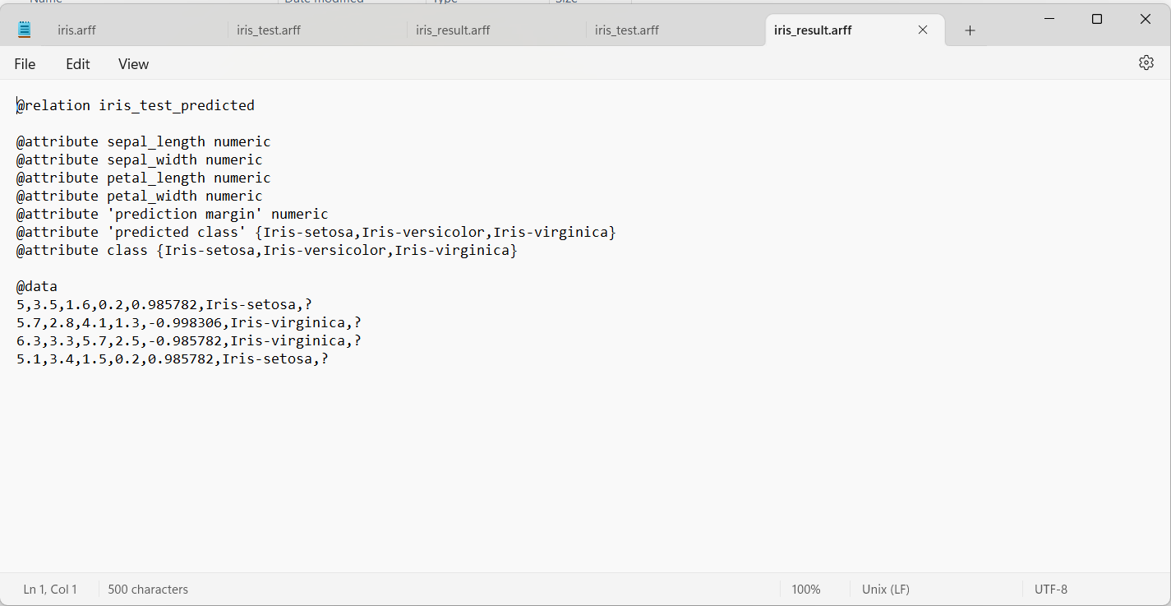

**Now the testing dataset is tested. The result is shown.**

**Calculation :**

**Correctly Classified Instances: 103 (99.04%)**

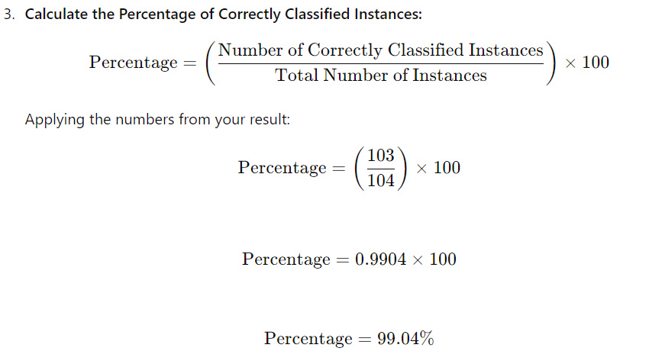

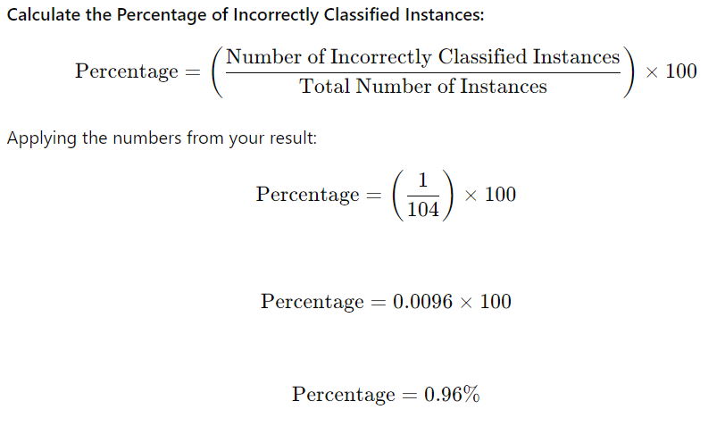

**Kappa statistics:**

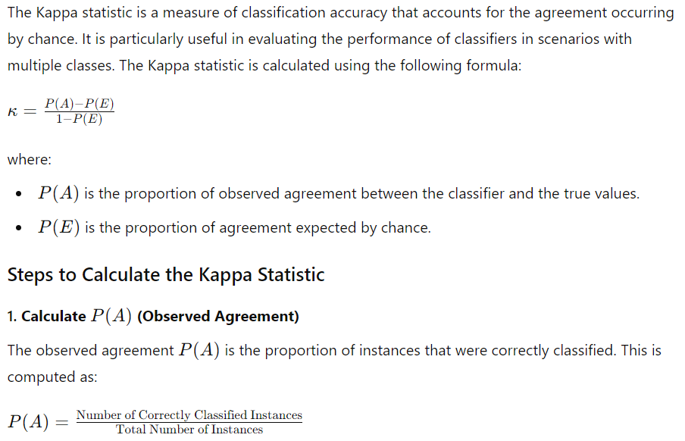

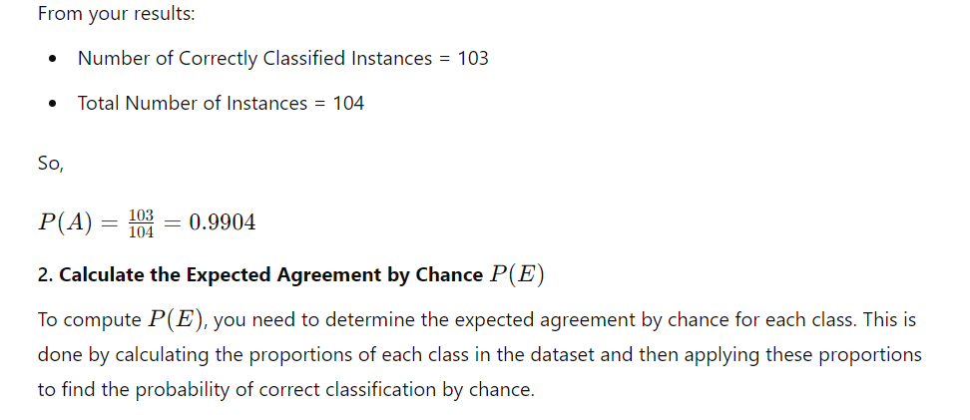

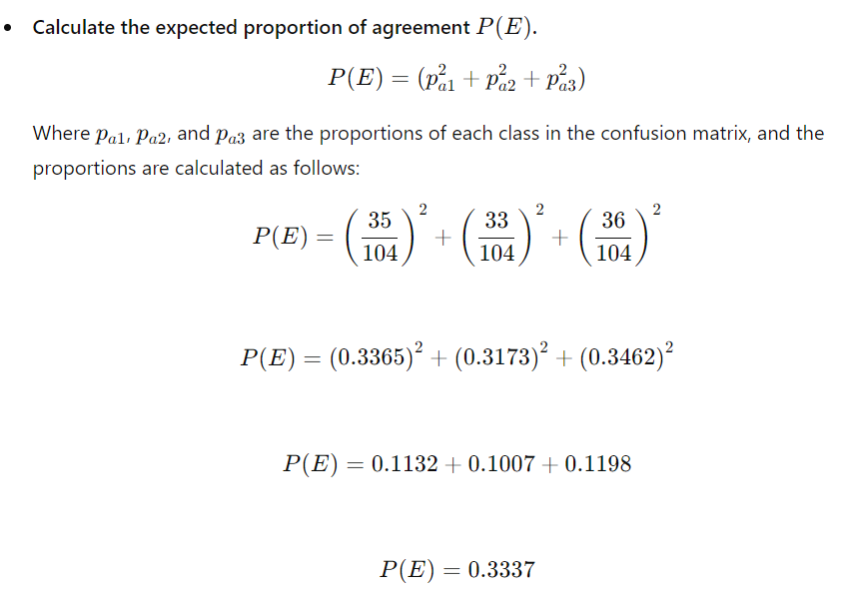

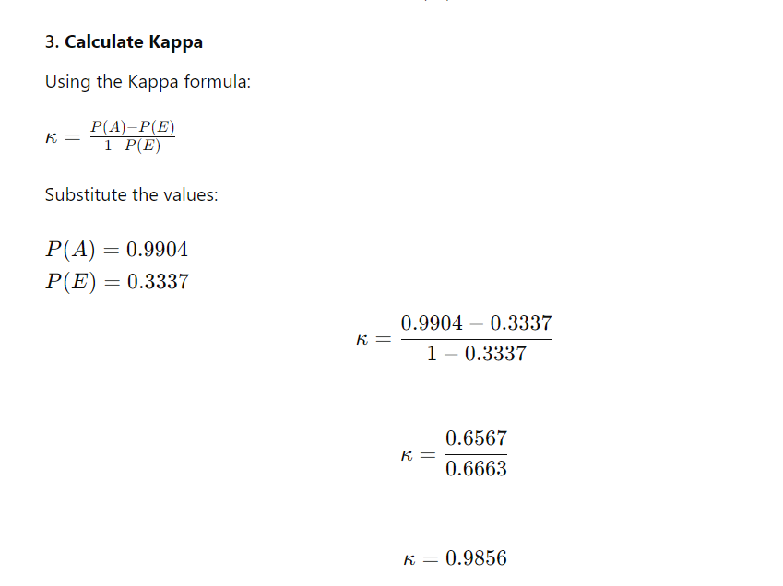

**Mean absolute error:**

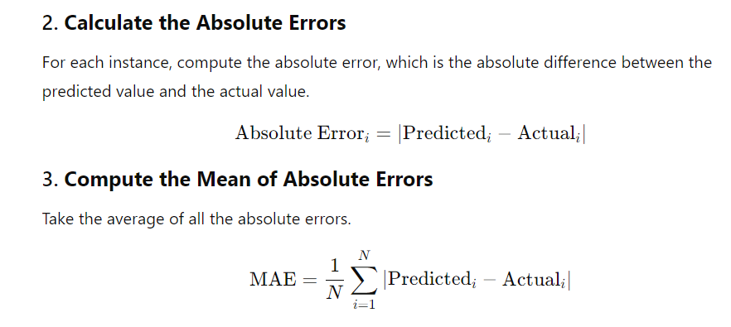

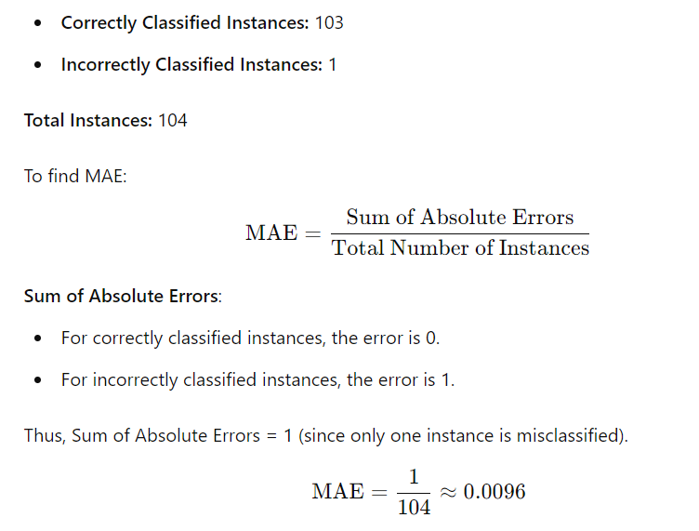

**Root Mean Absolute Error:**

